How to print a test label without running any scripts. On our operate run screen, select on the menu bar Settings->Printer Settings. Next, press the Apply Changes & Print Label button. A test label should print. The label will have a checker board test pattern. Note: No PLU is needed and the Label Width and Printer Contrast selections should not be disabled.
Operate run screen
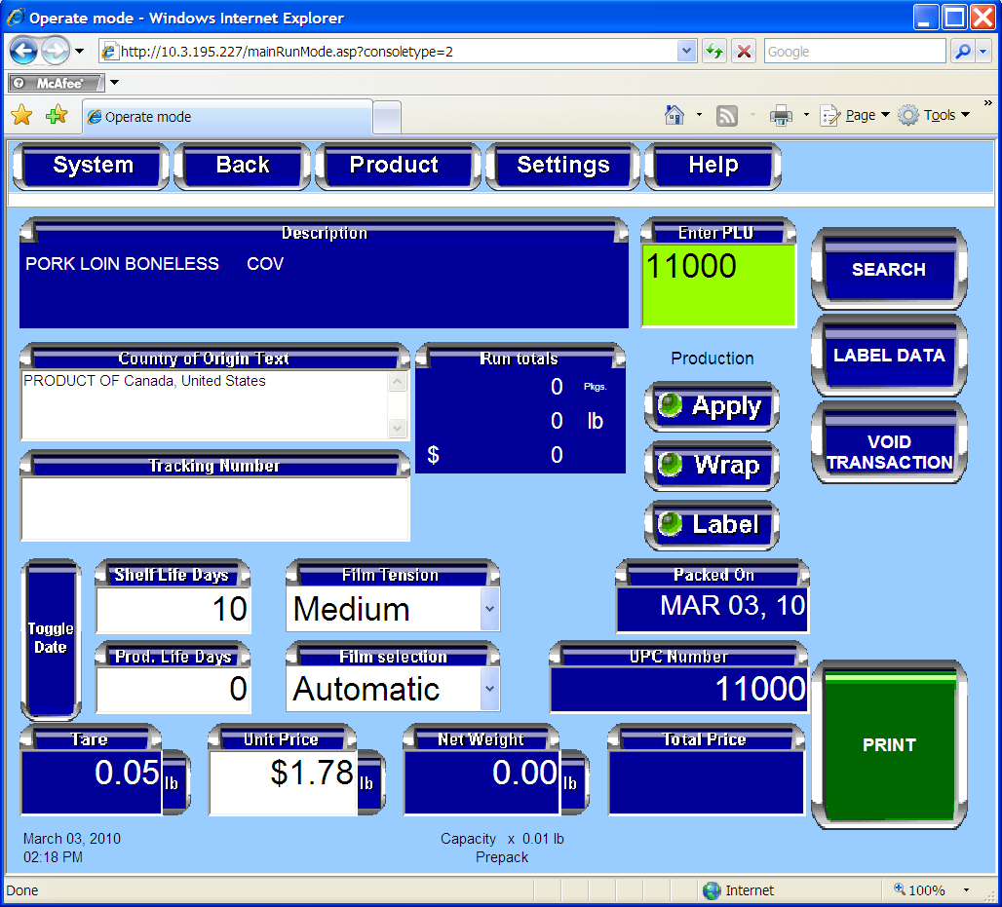
Printer Settings Page
